**Don't Let Your Website Be a Ghost Town: 5 Common Mistakes Small Businesses Make (and How to Fix Them!)**

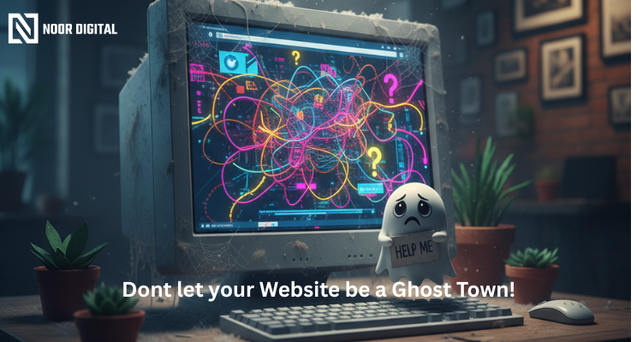

We get it: as a small business owner, you wear many hats! You’re CEO, marketing, customer service, and the person who un-jams the printer. Making a great internet presence can seem like solving a blindfolded Rubik’s Cube.

But here’s the deal: your website is not just an online brochure anymore; it’s your 24/7 salesperson, your lead magnet, and oftentimes the first impression potential customers are getting of you. Whether you are a small manufacturer, industrial supplier, or an MSME just starting, your website is usually the first handshake with any new clients. Why do so many amazing businesses sometimes hurt themselves without even knowing it?

At Noor Digital, we have seen it all! We are here to help you avoid these digital pitfalls and get your website for Manufacturers from becoming a deserted island into a thriving marketplace. Here are five common website mistakes small businesses make that may be losing you customers:

**Mistake #1:** The "Where's the Beef?" Navigation (Confused Menus) The Scenario: A prospective customer comes to your website, ready to learn more. They begin to click, essentially disappear into a poorly labelled maze of pages, and eventually CLICK! They are gone. They came for 'the beef' (your services!), but couldn't find the deli.

**The Fix**: Your navigation around your website should be as clear as a freshly cleaned window. Think intuitive, simple, and straightforward. "Our Services," "About Us," "Contact," and clearly labelled categories of products are your best friends. Do not make people search; they can just go to the next option.

**Mistake #2**: The "Mobile Maze" (Not Mobile-Friendly) The Situation: A potential customer hears about your great business and checks you out on their mobile device. They find really small text, images running off the screen, and general digital messiness. After pinching and zooming more times than they can count, they simply give up.

**The Fix** : More than 50% of all website traffic is coming from mobile devices. If your website is not responsive (meaning it does not adjust beautifully on different devices and screen sizes), you are literally pushing away 50% of your potential customers. A mobile responsive site is a must; it is no longer a luxury. It's like having a store front that only looks great when you view it from straight on and through a periscope. A completely useless tool!

**Mistake #3**: The "Ghost Town" Content (No journey established) The Situation: Your website looks nice! You have nice images and well-written content, but... what do you want me to do? There is not even a "Buy Now," "Get a Quote," "Call Us" or "Download Our E-book." It is akin to walking into a store that has kick-ass inventory in the window, but when you walk in, there is no one to pay.

**The Fix**: Every page on your website must have a purpose to walk someone through the next steps of what you want them to do. Call you? Email you Please do not make your potential customer guess! Make your "Call to Action" buttons distinctive so they can see them and encourage the customer to action with copy that describes what delight awaits them.

**Mistake #4**: The "Snail's Pace" Site (Slow Loading Times) The Situation: You click a link, and the little loading wheel spins and spins and spins. After 3-5 seconds (an eternity in Internet time), you are gone. Nobody has time for a slowsite, especially when they are looking for a solution to their problem.

**The Fix**: Google actually punishes slow websites, and users abandon them quickly. Optimize your images, leverage browser caching, and make sure your hosting is top of the line. A fast site is not just courteous; it's important for SEO and keeping your visitors happy. Think of it as opening the doors of your store on time instead of making your customers wait outside in the rain!

**Mistake #5**: The "Set It and Forget It" Syndrome (Neglected Critical Updates & Search Engine Optimization (SEO) The Situation: Your website was recently developed 5 years ago, looks ancient and hasn't had a new piece of content since. It's collecting digital dust, and search engines are treating it as an old artifact of the past.

**The Fix**: Your website requires periodic love and attention! Regularly update your content, write blog posts relevant to your profession or industry, and be aware of basic SEO (Search Engine Optimization). In other words...when you are active and up-to-date, you are telling Google you are active and an authority worth ranking in SERP. An updated website is a living, breathing asset, not an old dusty photo album.

Are You Prepared to Transform Your Website for Industrial and MSME Into a Lead-Generating Machine? Do not allow these common mistakes to prevent you from achieving your small business goals! Your website is your most cherished digital asset, and with a few best practice tips, it can become your strongest employee.

At Noor Digital, we help manufacturers and industrial and MSME businesses create stunning, highly advanced functional websites that generate leads and help the business grow online.

**Let's chat about how we can transform your online presence.** Visit us at: [**www.noordigital.in**](http://www.noordigital.in)

#SmallBusinessTips #WebsiteDesign #DigitalMarketing #LeadGeneration #NoorDigital #WebDevelopment #SEO #BusinessGrowth #OnlinePresence #WebsitesForManufacturers #IndustrialWebsite #MSME #B2BWebsite